# Main Objective of the Project:

Our main objective is to create an independent and complete end-to-end platform for users to make stock investment choices. This platform will encompass the entire process, from the underlying layers to the application layer, using the architecture of model prediction + trading strategies+ user platform. The model prediction involves training five predictive models through machine learning. The trading strategies consist of two directions: machine learning-based trading strategies that utilize the trained models to make stock predictions and invest based on different strategies, and technical strategies that employ classical financial trading strategies. The user platform encompasses five major functionalities:

* Personal account management
* Posting and commenting
* User private messaging
* Liking and following
* Selecting models and trading strategies for backtesting historical stock data

# Introduction to Trading Strategies

## buy_and_select_when_sell:

* If the current position is empty, the model is used to predict whether today's opening price is higher than yesterday's price based on historical data. If the price is lower than yesterday, indicating no upward trend, no trading is executed, and a short position is maintained. If the price is higher than yesterday, indicating an upward trend, all stocks are bought.
* If the current position is open, the machine learning model is used to predict whether today's opening price is lower than yesterday's based on historical data. If the price is lower than yesterday, indicating a downward trend, all stocks are sold. If the price is higher than yesterday, indicating a continuing rise, no transaction is executed, and the position is held.
* Result: Taking the stock of Guohua Network Security as an example, the yearly benchmark return represents the benchmark annual return rate without using our strategy, which is -7.797244130606297% in this example. The yearly return represents the stock annual return rate achieved after using our buy_and_select_when_sell strategy, which reaches 39.26212925616164%, showing a significant improvement. Furthermore, in different time periods and different stocks, there are different scenarios. In some cases, stocks continue to decline, with a negative benchmark return rate. The return rate after using our strategy is also negative, but our strategy can make the annual return rate relatively smaller compared to the benchmark return rate, indicating less decline, thus achieving the goal of the strategy.

## buy_and_sell_with_ma

buy_and_sell_with_ma is a strategy that combines machine learning with a technical trading strategy called moving average line strategy. Its main objective is to determine the timing of buying and selling based on the crossover of price's moving average lines.

The specific process is as follows:

* For each trading day, check if the predicted closing price for the day is higher than the actual closing price of the previous day. If it is, further evaluate the crossover of the moving average lines.
* Calculate the averages of the short-term and long-term moving average lines. I set the window size of the short-term moving average line to 5 days and the window size of the long-term moving average line to 20 days. Add the selected price data and divide it by the window size.
* If the short-term moving average line is greater than the long-term moving average line, indicating a positive crossover, a buy operation is performed. Calculate the number of stocks that can be bought based on the opening price for the day. Calculate the actual funds spent based on transaction fees. Calculate the funds obtained after selling stocks based on the actual closing price for the day. Calculate the daily returns. Write the transaction record to a log file.

In summary, a buy operation is performed when the short-term moving average line crosses above the long-term moving average line, and a sell operation is performed when the short-term moving average line crosses below the long-term moving average line.

# Future Directions:

* Model Selection: Currently, the models include LSTM, linear regression, SVM, random forest, and GRU. In the future, we aim to select more advanced models to achieve better prediction performance and consequently improve the return.
* Strategy Adjustment: When creating machine learning strategies, we will consider the features of the machine learning models more extensively to devise strategies that higher return rates.

# Introduction to Platform

Our platform is meticulously architected to offer users a seamless experience with an intuitive interface, enabling them to perform fundamental operations effortlessly. We have successfully deployed key modules such as User Registration,Permission Management, Posting & Direct Messaging, Follow and Like, Forecast Task Addition, and System Notifications.

## Technology Stack:

* Spring Boot: Serves as the backbone, streamlining the setup, configuration, and execution of applications.
* Spring MVC: Acts as the web framework, adeptly handling user requests and routing them to appropriate services.
* MyBatis: Functions as the data access layer, offering simplified database interactions and versatile control.
* MySQL: Our primary database, entrusted with the storage of user data, posts, and pivotal information.
* Redis: Employed to cache data that’s frequently accessed, thereby enhancing system responsiveness and efficiency.
* Kafka: Integrated as the message queue system, it’s instrumental in managing voluminous data streams, logging, and real-time analytics.

Our selection of technologies is strategic, aiming to guarantee the platform’s high performance, scalability, and security. This synergy of technologies equips us to deliver a robust and agile network service platform to our users.

## Post Detail Page

Posts, comments and private letters are implemented Similarly. When the button on the website is clicked , the server then processes this request, creating a new record in the database and returning a JSON response indicating success or failure. These features are integrated with client-side scripts that handle form submissions asynchronously, providing a seamless user experience without full page reloads. Server-side, extensive use of AJAX ensures that user interactions are quick and non-blocking.

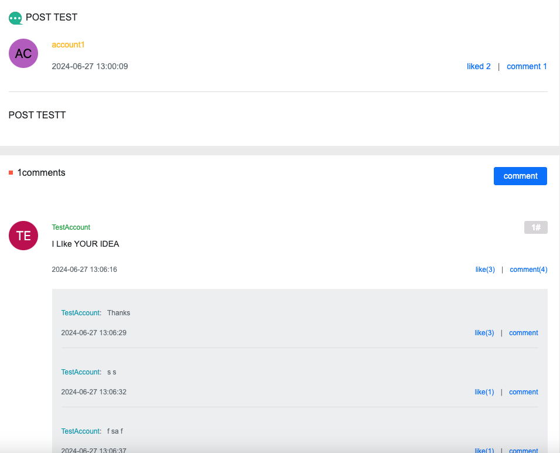

## Message Page

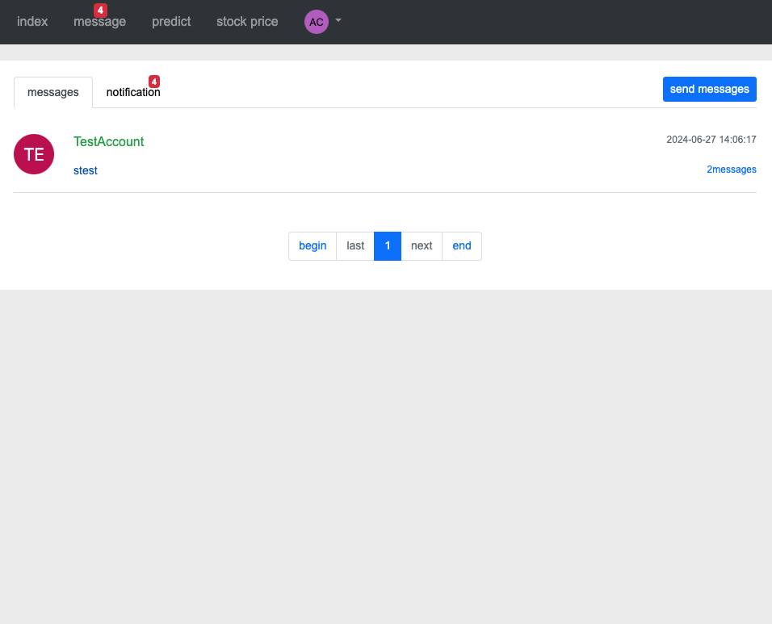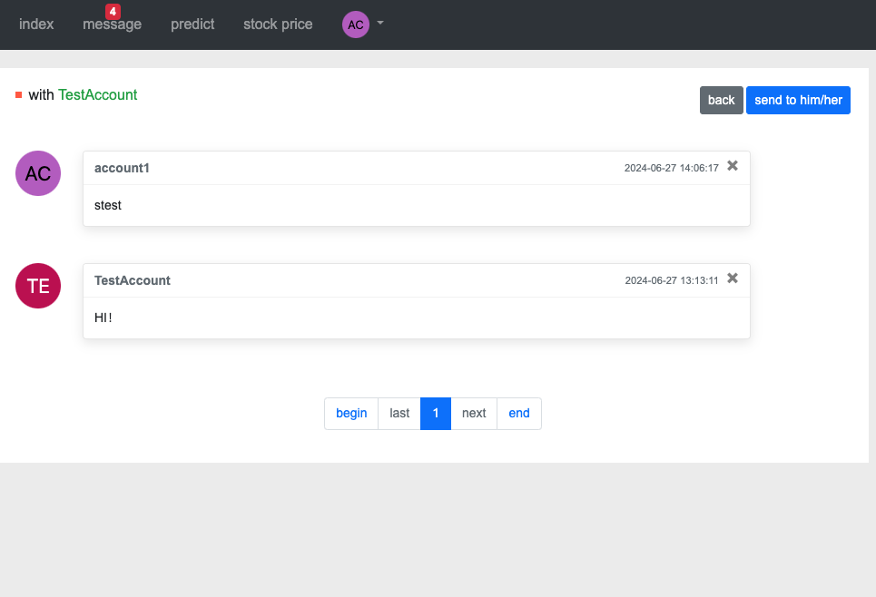

## In the message page, users can see all the messages related with the current user. Also the platform allow users to send private to certain users.

## Stock Prediction Page

## Users can submit the stocks they want to predict, along with the strategies and models they use. Users can also determine the stock interval they wish to forecast.

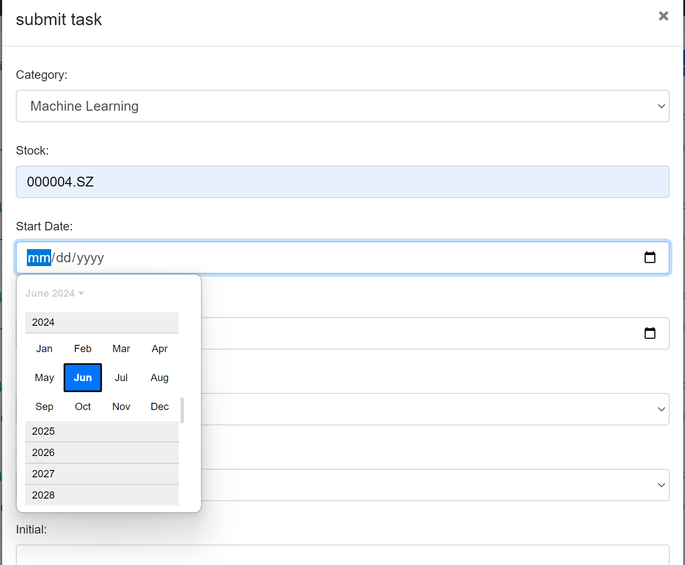

If users choose to use machine learning for stock prediction, the available strategies and models will be different from when users choose to use technical analysis. Under the technical analysis approach, users cannot select specific models; instead, they can choose from different strategies.

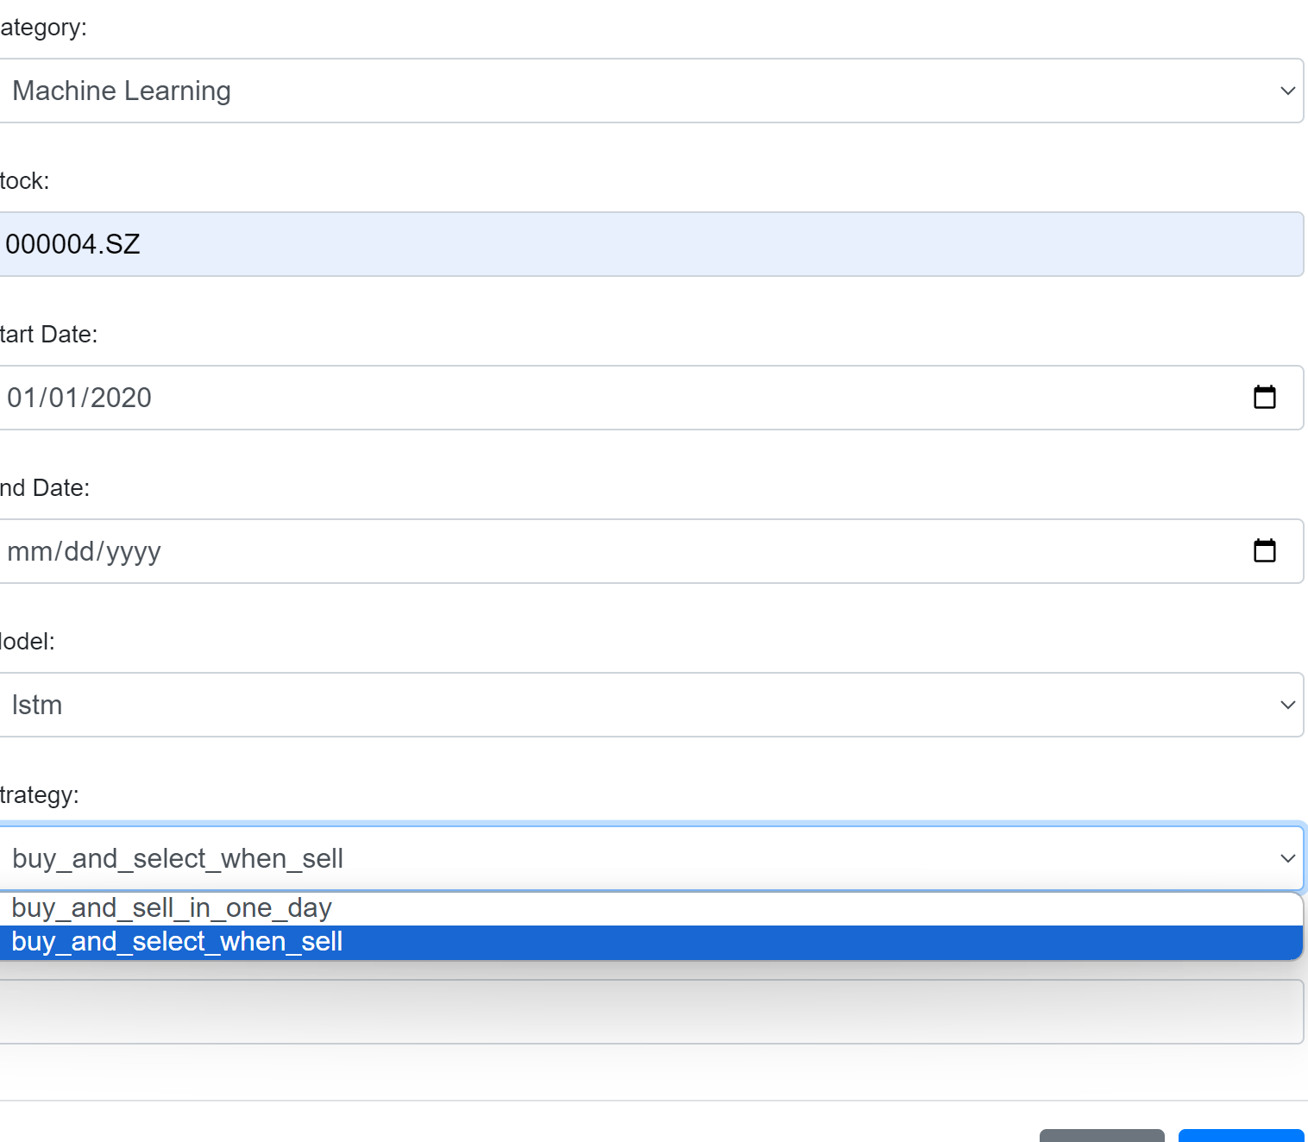

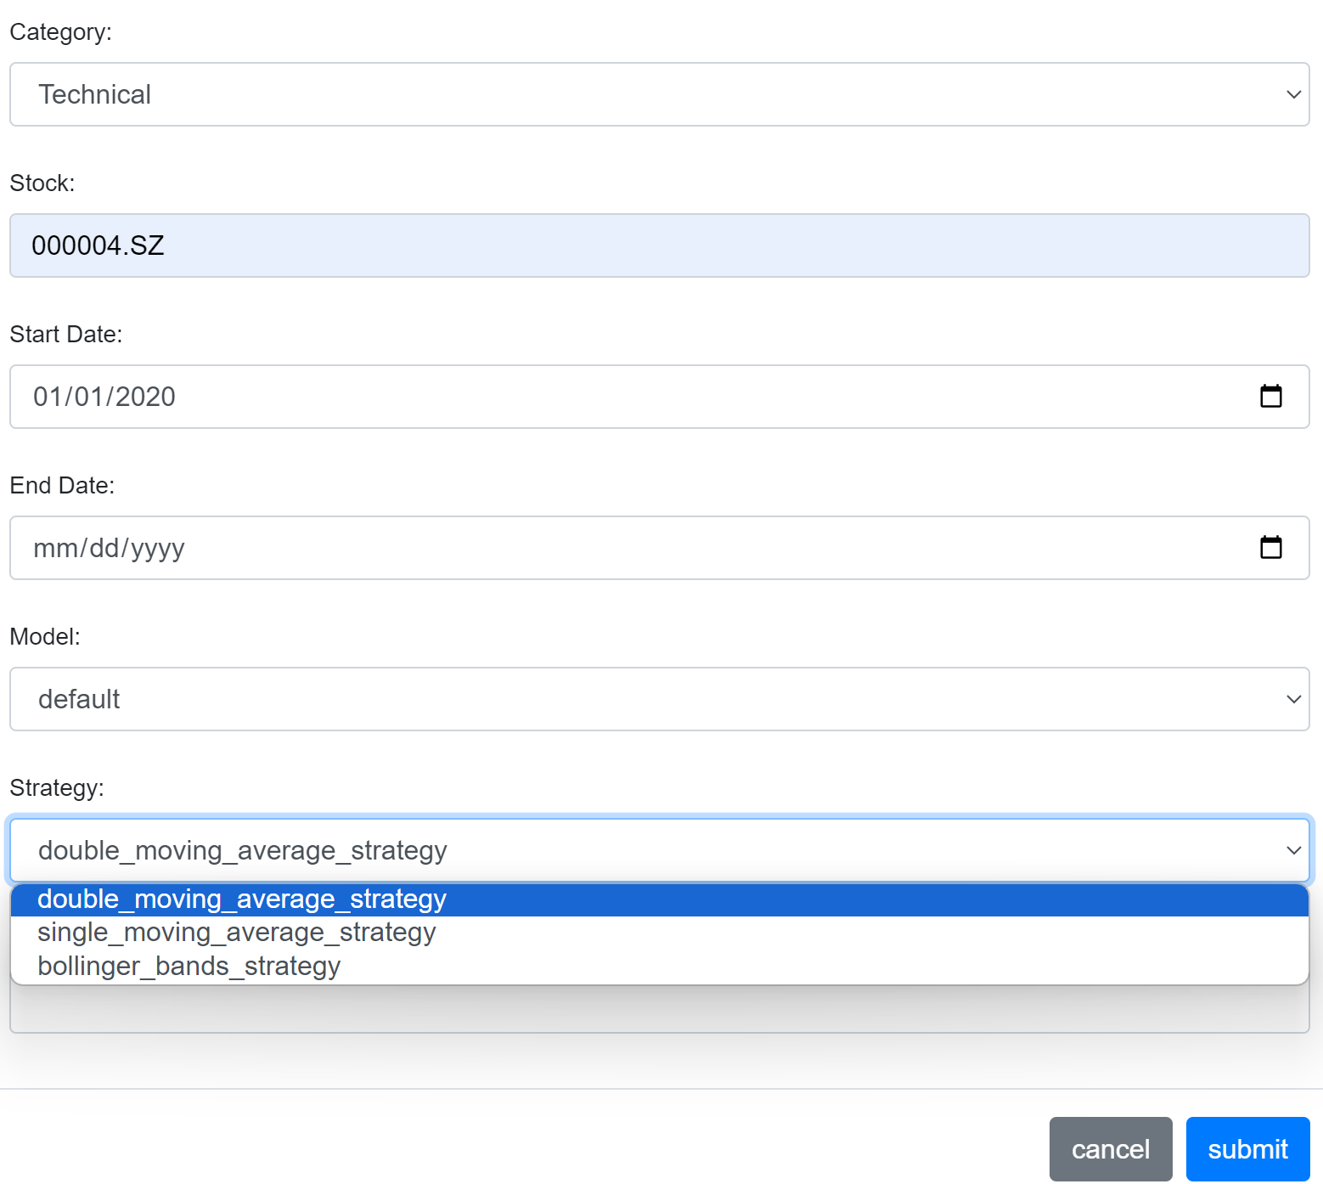

After a user submits a prediction task, a new record will be added to the task list. By clicking the "View the Results" button, users can see the results of the stock prediction.



The results will be presented from various perspectives, such as prediction result images, return rate, benchmark return rate, and so on.

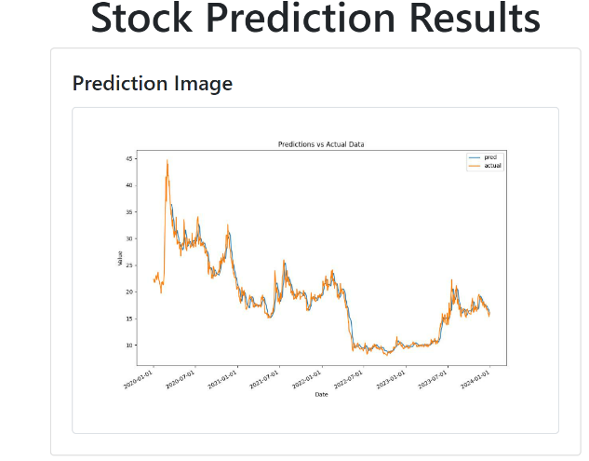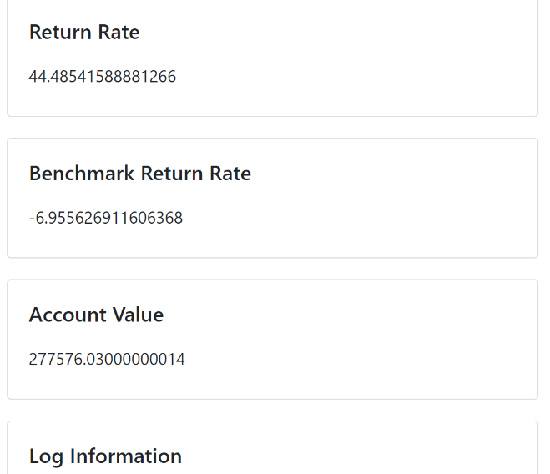

## Stock Display Page

The stock display page is divided into two main tabs: "All Stocks" and "My Following."

In the "All Stocks" TAB, users can view the basic information of all stocks in the market. Basic information for each stock includes: ticker symbol and stock name. Next to each stock is a "Follow" button, which users can click to add the stock to their follow list.

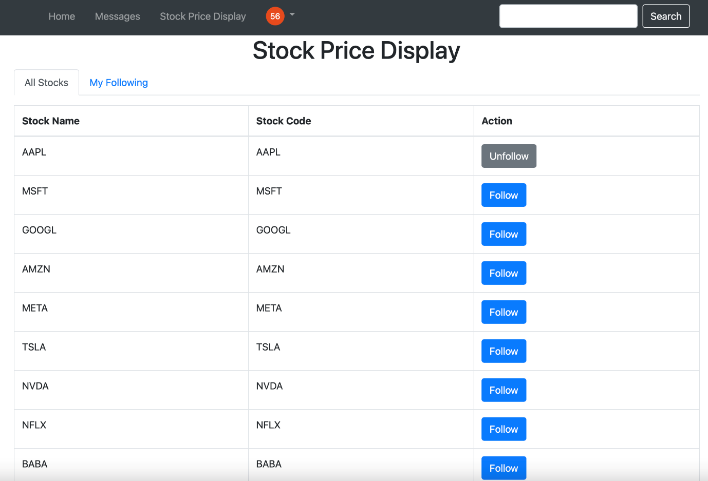

In the "My Following" TAB, users can view the details of the stocks they follow. Details include:

Ticker symbol, stock name, current price, Opening price, High price, low price, previous day's closing price, price changes, basic company information (company name, exchange, industry, website, country, etc.) Users can have a deeper understanding of the stock they follow and make timely reactions to market changes through this TAB.

